Colour harmony refers to aesthetically pleasing arrangements of colours. In Interior Design, these are created through Colour Schemes. A Colour Scheme refers to a defined set of colours that are used together in a design or composition, to create visual harmony and convey a particular aesthetic or mood.

In order to select the appropriate colours for a successful colour scheme, it is important to understand some parameters that will play a role in the colour selection process. This includes whether or not the chosen colours are warm or cool as well as the orientation of a room.

## Defining Warm and Cool Colours

There are two ways we define colour as cool or warm:

1. Categorising the hue of the colour (fig 6):

**Warm Colours** (e.g. red, orange): Evoke feelings of energy, warmth, and excitement. Used in lounges, restaurants etc.

**Cool Colours** (e.g. blue, green): Create a sense of calm, relaxation, and serenity. Used in bedrooms, clinics, spas etc.

**Neutral Colours** (e.g. beige, grey): Provide a versatile backdrop, allowing other colours to pop.



Fig.1. Canva (n.d.), Warm, Cool and Neutral Colour Hues

1. Defining the undertone of the colour in order to understand if it is warm or cool. Undertones define whether any colour is cool or warm in its essence and define the feeling of a colour (fig. 7). An undertone is a slight addition to a certain colour and belongs to either of the two categories mentioned above (warm or cool). For example, you can have a Cool Red paint, which has an undertone of blue. This means that in the pot of Red, one or two drops of blue have been added.

**Red, orange and yellow** undertones offer a **warmer** feeling to the hue of a colour.

**Blue, Green and Purple** undertones offer a **cooler** feeling to the hue of a colour.

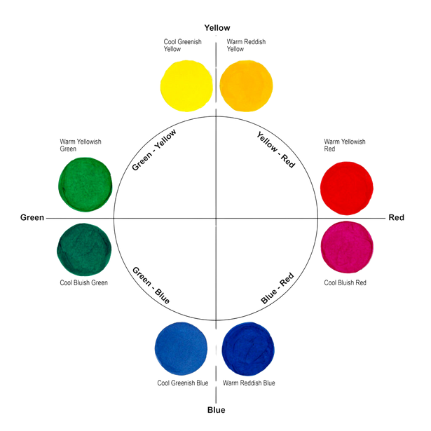

Fig. 2. Canva (n.d.), Warm and Cool undertones in colours

## Room Orientation and Colour Selection:

When it comes to selecting a colour scheme for your project, the direction a room faces can significantly impact how colours are perceived. North and South facing rooms interact differently with natural light, affecting the overall ambiance and mood. Understanding how to apply cool and warm colour schemes can help you make the best choice for each room. Additionally, considering the hemisphere you live and work in can further refine your choices, as the quality of light varies between the Northern and Southern Hemispheres.

#### North-Facing Rooms (in the northern hemisphere)

Characteristics:

Receive indirect, cooler light throughout the day.

Tend to feel darker and colder, especially during the winter months.

In order to balance the “cold” feeling a north facing room naturally has, it is advised to implement warm colour schemes, or look at colours with warm undertones to them. The latter means that you are not limited in your choice of colour.

Colour Recommendations:

Warm Colours:

Soft Yellows: These can add a sense of warmth and brightness. Consider shades like buttercream or pale gold.

Warm Whites: Opt for whites with a hint of yellow or beige, such as ivory or vanilla.

Earthy Tones: Light terracotta, warm taupe, and honeyed browns can make the space feel cosier.

Warm Greens: Olive or moss green can add depth and warmth without overwhelming the space.

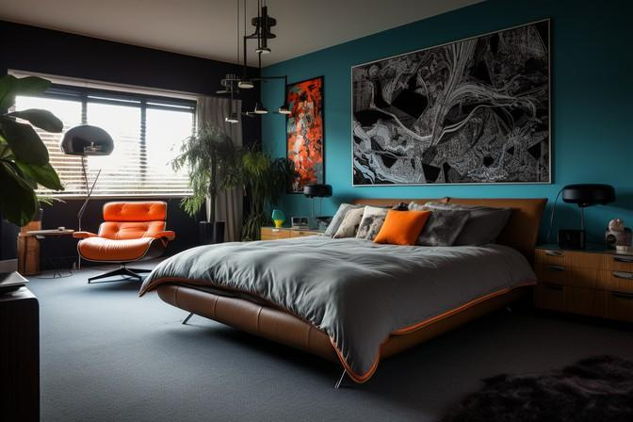

Fig. 3. Pixabay (n.d.), Warm Colour Scheme (all colours have warm undertones)

#### South-Facing Rooms (in the northern hemisphere)

Characteristics:

Benefit from ample natural light, often with a warm and golden quality. Can handle bolder and cooler colours due to the abundance of light.

South facing rooms can afford to take both warm and cool colour schemes. However, as these rooms are exposed to a significant amount of direct sunlight, they often are quite warm.

Implementing a cooler colour scheme in these rooms can bring the temperature of these rooms down “virtually”.

Colour Recommendations:

Cool Colours:

Soft Blues: Light blues, like sky blue or powder blue, can create a refreshing and airy atmosphere.

Cool Greens: Mint, sea foam, or sage green can introduce a calming effect.

Cool Whites: Crisp whites with blue or grey undertones, such as pure white or pearl grey, work well to balance the natural warmth.

Deep Blues and Greens: Navy or emerald green can make a dramatic statement, without making the room feel dark.

Jewel Tones: Sapphire, amethyst, or ruby can add richness and sophistication.

## Differences Between the Northern and Southern Hemispheres

The hemisphere you live in will affect the quality and direction of natural light in your project:

**Northern Hemisphere:** Includes countries like the United States, Canada, the United Kingdom, Germany, and Japan

North-Facing Rooms: Tend to receive cooler, indirect light.

South-Facing Rooms: Receive warm, direct light throughout the day.

**Southern Hemisphere**: Includes countries like Australia, New Zealand, South Africa, Brazil, and Argentina.

North-Facing Rooms: Receive warm, direct light, similar to south-facing rooms in the Northern Hemisphere.

South-Facing Rooms: Receive cooler, indirect light, similar to north-facing rooms in the Northern Hemisphere.

#### Tips for Both Hemispheres and Room Orientations

1. Test Samples:

 Paint small sections of a wall, and observe how the colour changes throughout the day.

Natural light can significantly alter the appearance of paint.

1. Consider the Function and Mood:

 Think about the room's purpose. A bedroom might benefit from calming hues, while a living room could handle more vibrant tones.

1. Harmonise with Furnishings:

 Ensure your chosen colour scheme complements and implements your chosen furniture, flooring, and overall decor.

1. Layer with Lighting:

 Use artificial lighting to balance and enhance the chosen colour scheme. Warm light bulbs can add cosiness to cooler rooms, while cooler bulbs can maintain the fresh feel of naturally warmer rooms.

By carefully selecting colour schemes that align with the natural light in your north and south- facing projects, and considering the hemisphere you are in, you can create harmonious and inviting spaces tailored to their unique lighting conditions.

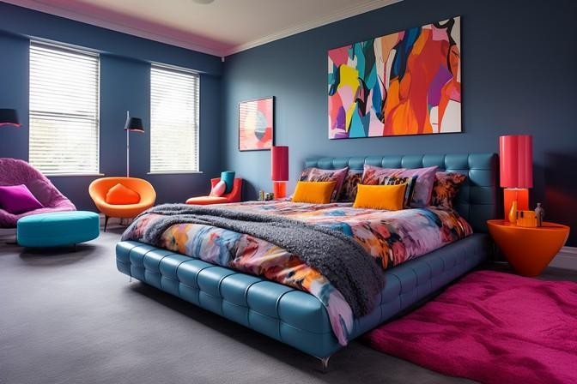

Fig. 4. Canva (n.d.), Cool Colour Scheme (all colours have cool undertones)

## Creating Colour Schemes based on the Colour Wheel

In interior design, a colour scheme refers to a defined set of colours that are used together to create a cohesive and aesthetically pleasing finish in a space. These colours work together to set a tone, mood, and overall atmosphere. A well-chosen colour scheme can enhance the design, functionality, and emotional impact of a room.

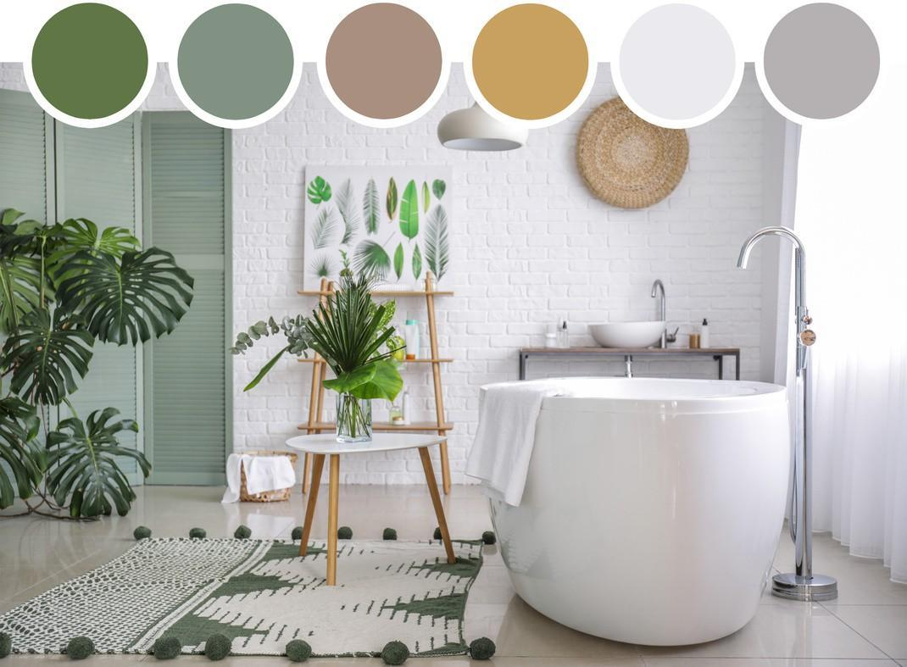

Fig. 5. Canva (n.d.), A Colour Scheme Presentation

How to create a Colour Scheme:

1. **Determine the Room’s Purpose**: Consider how the room will be used. For example, bedrooms can benefit from calming colours, while dining rooms can handle more vibrant hues.
2. **Choose a Base Colour:** Select a primary colour that will dominate the room. This is often a neutral or a colour that matches existing furniture or fixtures.
3. **Select Complementary and Accent Colours:** Choose colours that complement the base colour. Use the colour wheel to find complementary, analogous, or triadic options. Accent colours can add interest and highlights but should be used sparingly.
4. **Consider the Lighting**: Natural and artificial lighting can alter the perception of colours. Test colours under different lighting conditions to see how they change.
5. **Balance and Proportion:** Use the 60-30-10 rule: 60% of the room in the dominant colour, 30% in a secondary colour, and 10% in an accent colour. Ensure a balanced distribution to avoid overwhelming the space.
6. **Incorporate Textures and Patterns**: Add depth and interest through different textures and patterns that align with your colour scheme.

## Types of Colour Schemes:

### MONOCHROMATIC

Description: Uses variations of a single colour hue.

Example: Different shades of blue ranging from light sky blue to deep navy.

Fig. 6. Canva (n.d.), Colour Wheel

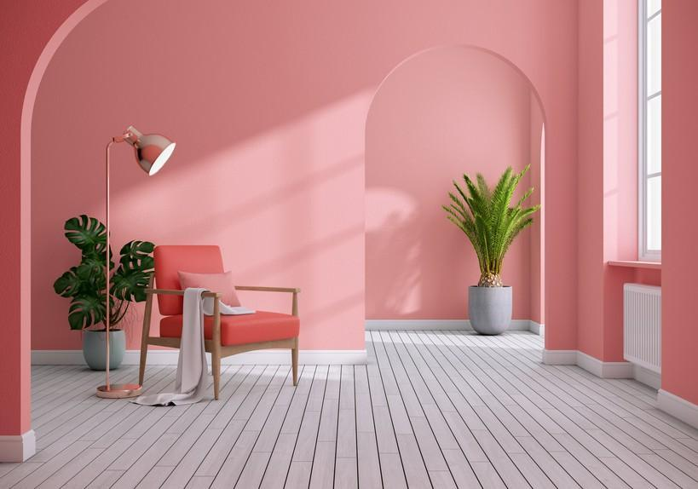

Fig. 7. Canva (n.d.), Examples of Monochromatic Colour Schemes in application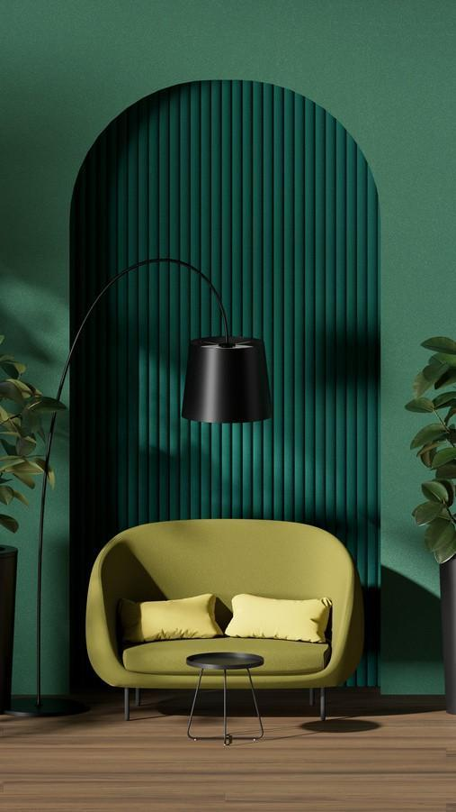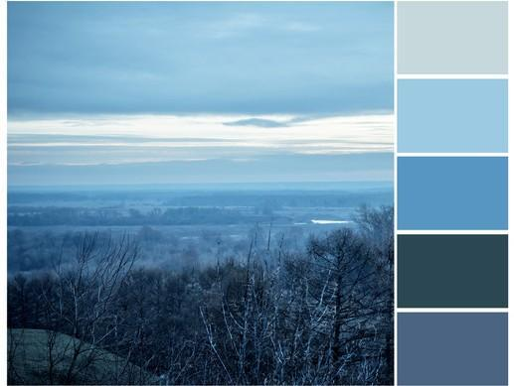

### ANALOGOUS

Description: Combines colours that are adjacent to each other on the colour wheel.

Example: Red, orange, and yellow or blue, green, and teal.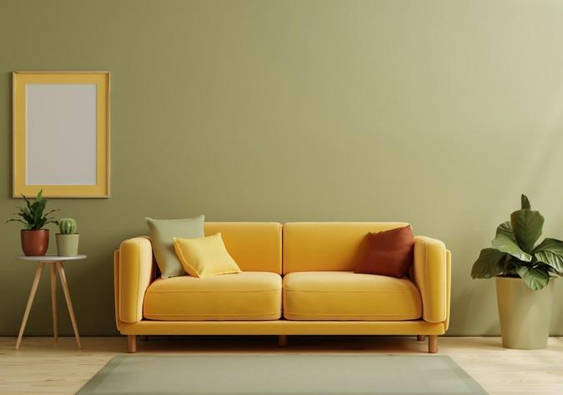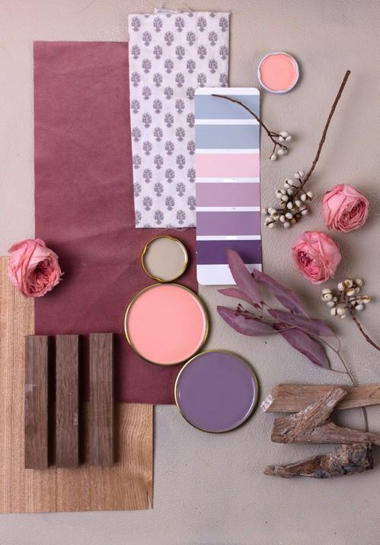

Fig. 8. Canva (n.d.), Examples of Analogous Colour Schemes in application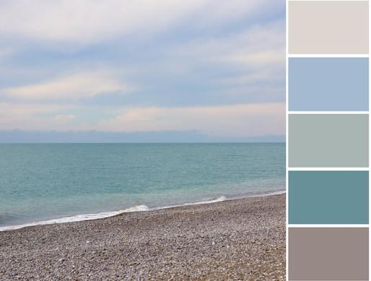

### COMPLIMENTARY

Description: Utilises colours that are opposite each other on the colour wheel.

Example: Red and green, blue and orange, or purple and yellow.

(See Fig. 9)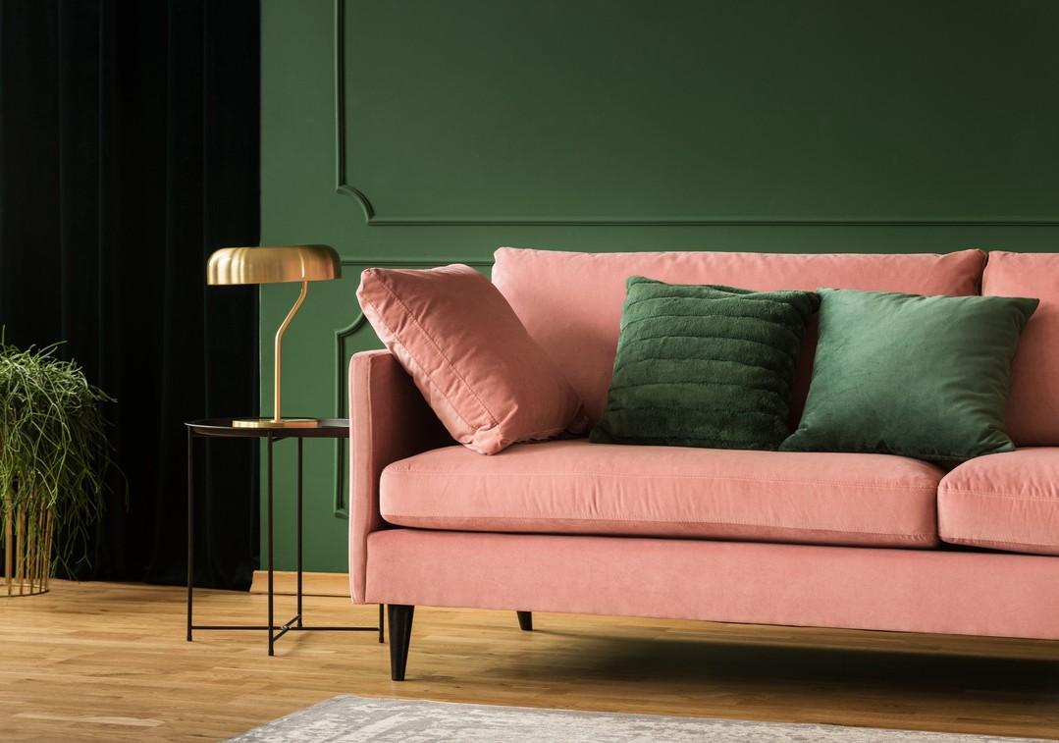

Fig. 9. Canva (n.d.), Examples of Complementary Colour Schemes in application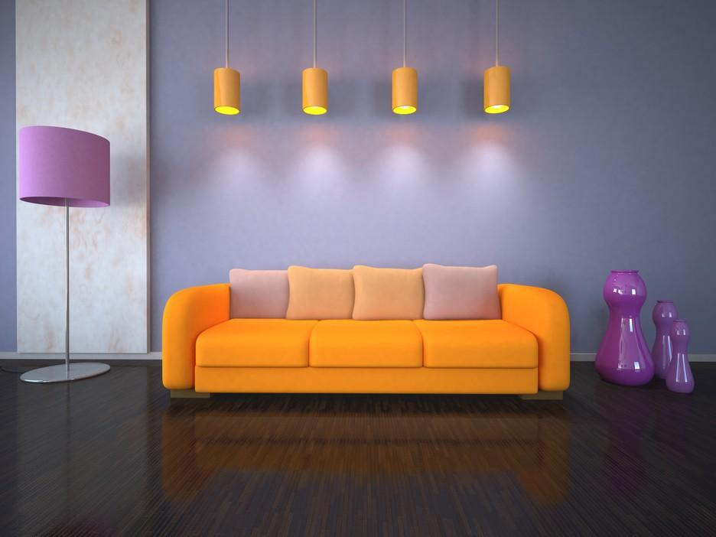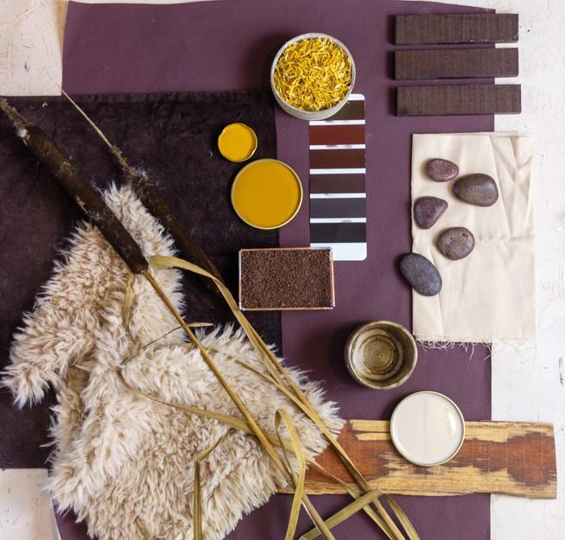

### SPLIT COMPLEMENTARY

Description: Similar to complementary, but uses one base colour and two adjacent colours to complement each other.

Example: Blue with yellow-orange and red- orange.

(See Fig. 10)

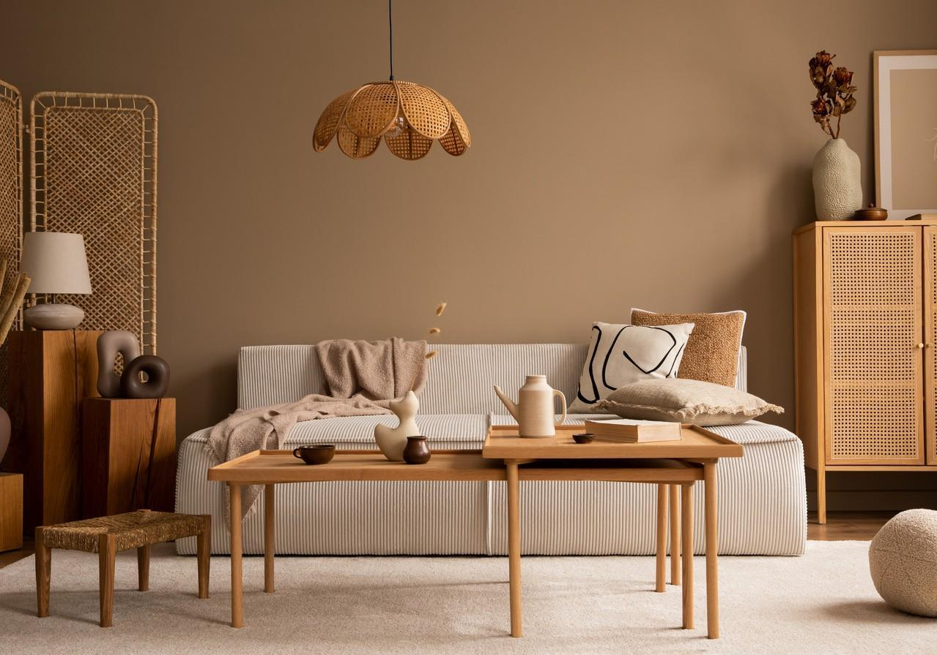

Fig. 10. Canva (n.d.), Examples of Split Complementary Colour Schemes in application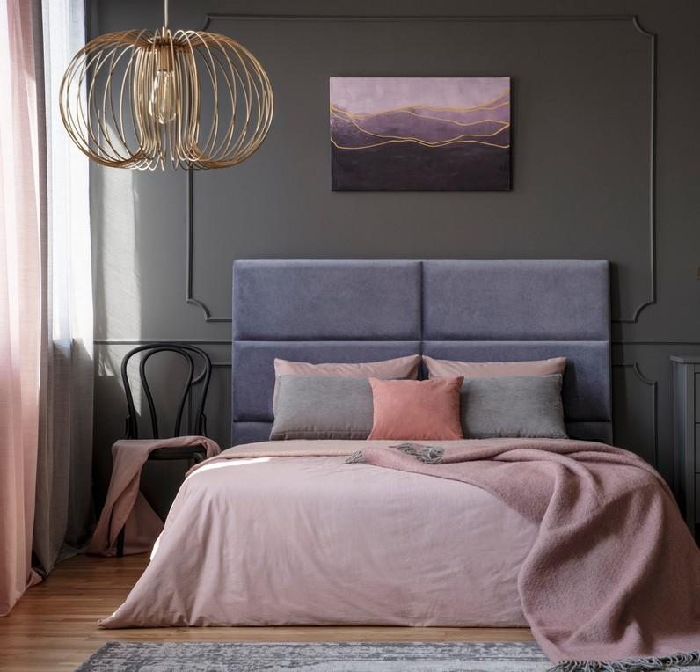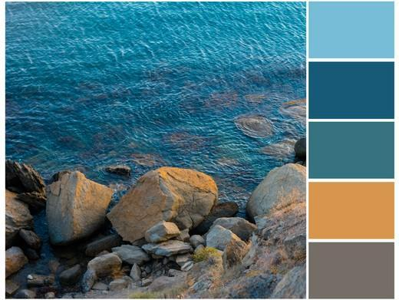

### TRIADIC

Description: Involves three colours equally spaced around the colour wheel.

Example: Red, blue, and yellow, or green, purple, and orange.

(See Fig. 11)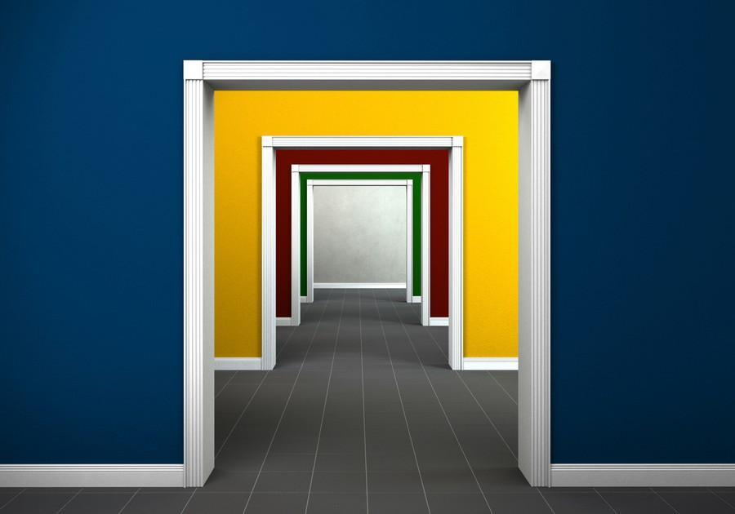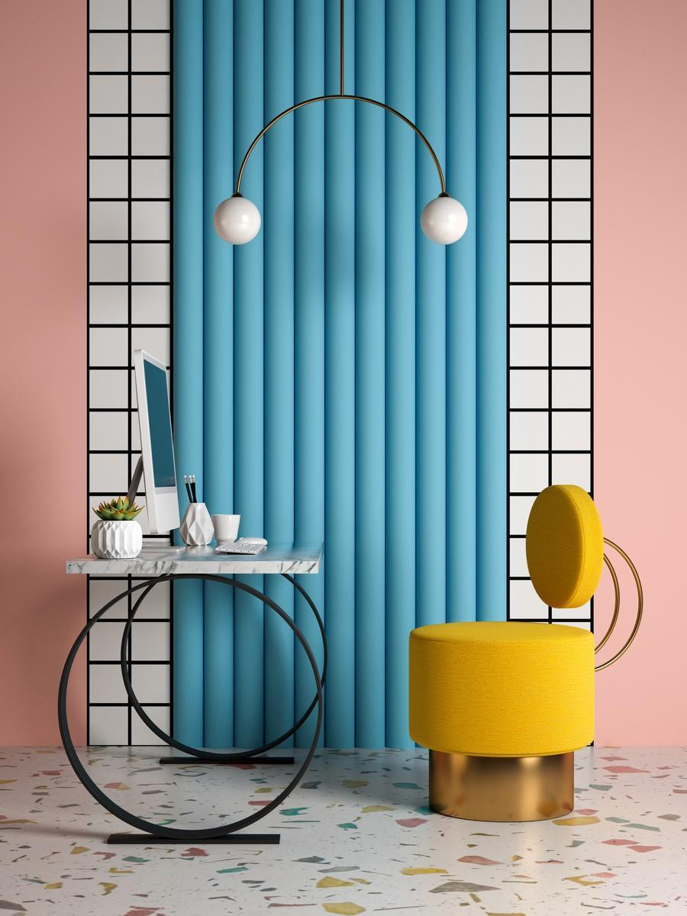

Fig. 11. Canva (n.d.), Examples of Triadic Colour Schemes in application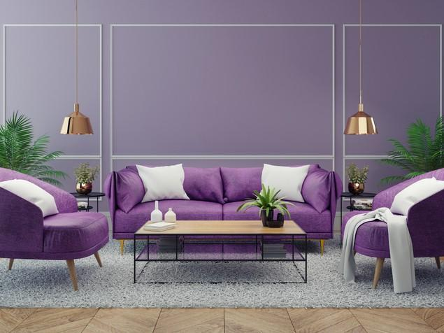

### TETRADIC

Description: Uses two sets of complementary colours.

Example: Red and Green with blue and orange.

(See Fig. 12)

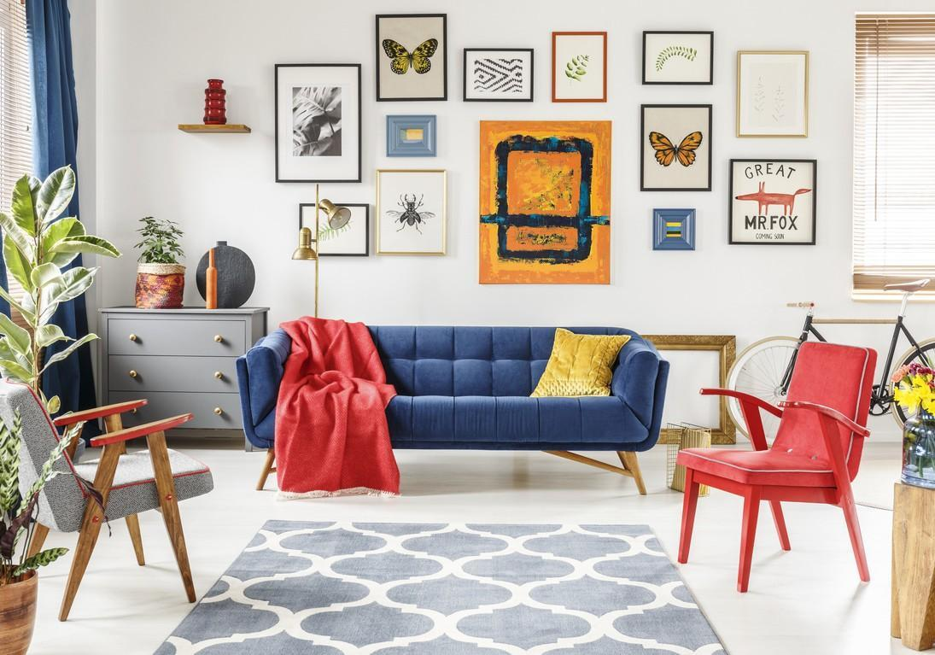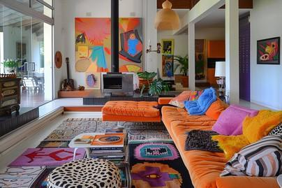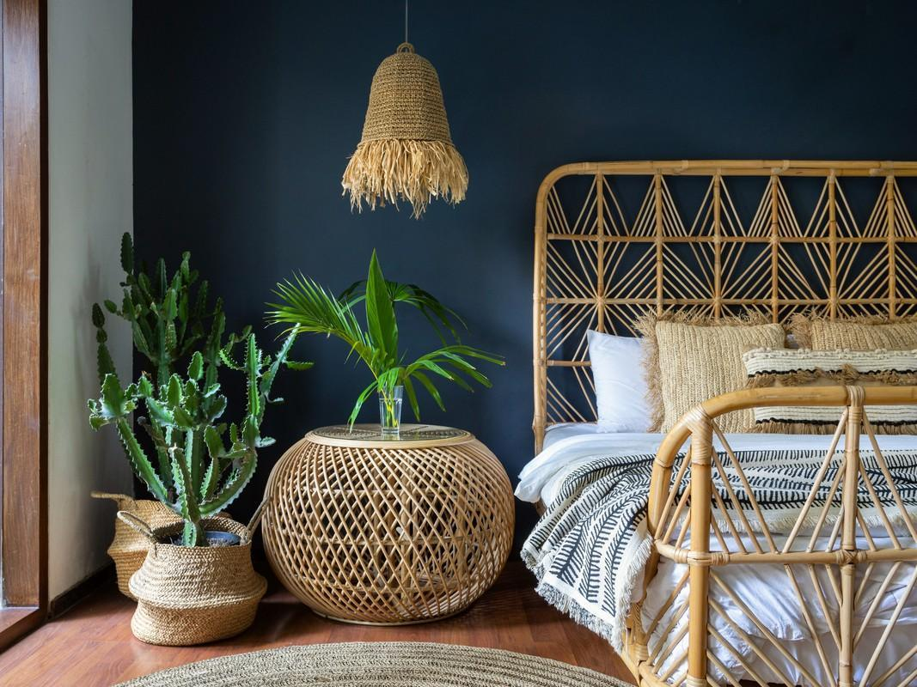

Fig. 12. Canva (n.d.), Examples of Tetradic Colour Schemes in application

By understanding the basic principles of colour schemes, you can create a harmonious and visually appealing interior design that speaks to your client’s needs, the room’s intended function as well as reflecting your style as a designer.